SSL VPN deployment (Config Generator)

# Prerequisite

Public IP should be configured on ISP1 interface. See other manual.

JDN Standards - Fortinet - ISP1 Office interface aanpassen:

<http://meso.jandenul.com/meso-webtop/drl/objectId/090236ed84816e9c>

# Installation

Open the ConfigGenerator on Feman VM.   
C:\Program Files (x86)\JDN\ConfigGenerator\ConfigGenerator.exe

Filter on the correct site

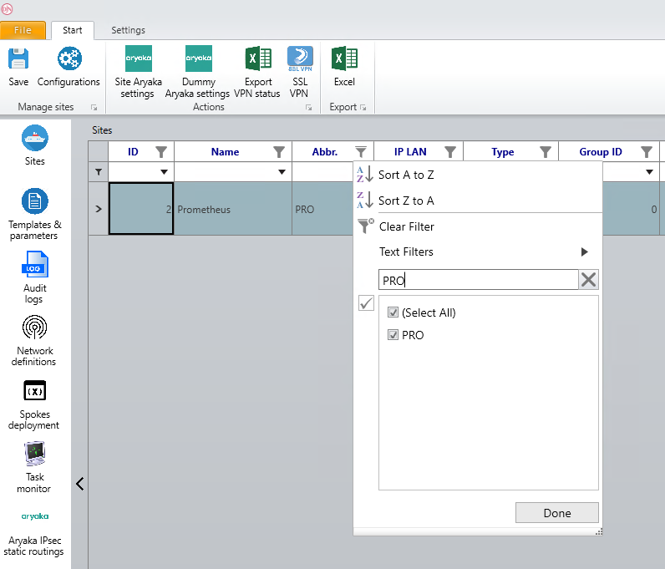

Click on the “SSL VPN” button.

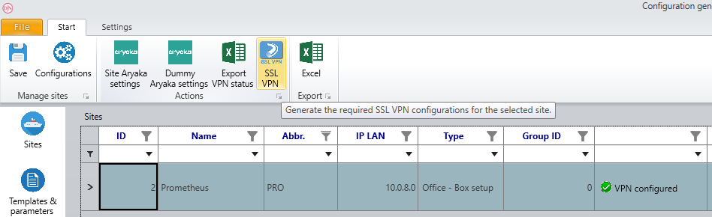

Confirm your action.

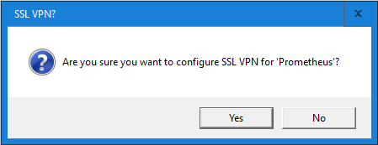

Save the config files.

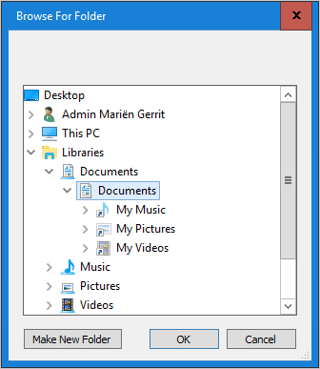

This takes a few seconds.

The srv_ldap password can be found in the “PRO-SSL VPN - Add new user-20190101-010101.conf” along with the AD group and OU location file.

The folder with the files will open and script execution will be confirmed.

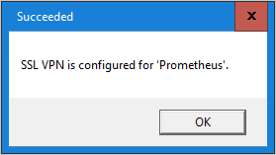

Go to FortiManager and sync the root config.

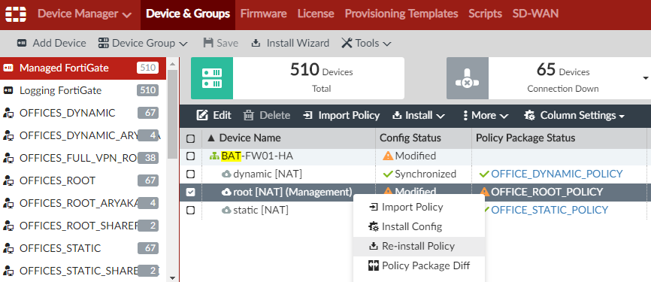

Add the Static VDOM to the “OFFICES_STATIC_SSL_VPN” group.

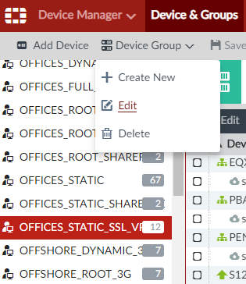

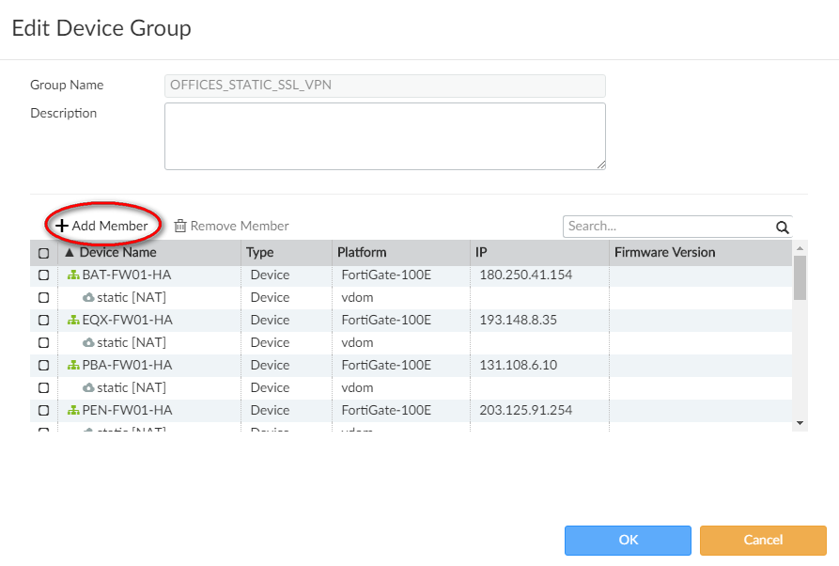

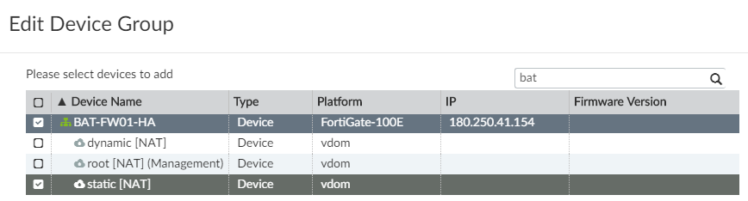

Change the static VDOM NAT to the Public IP.

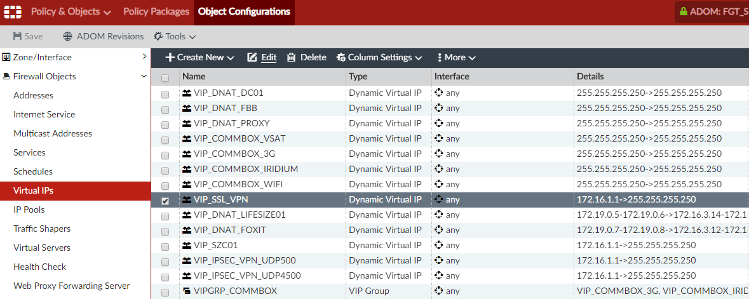

Filter on the office in the per-device mapping.

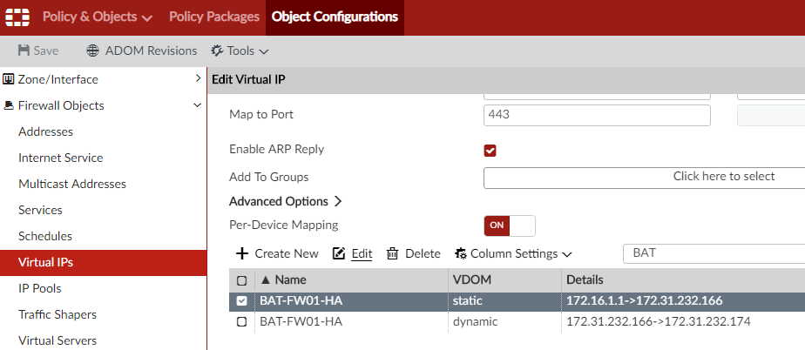

Fill in the public IP address.

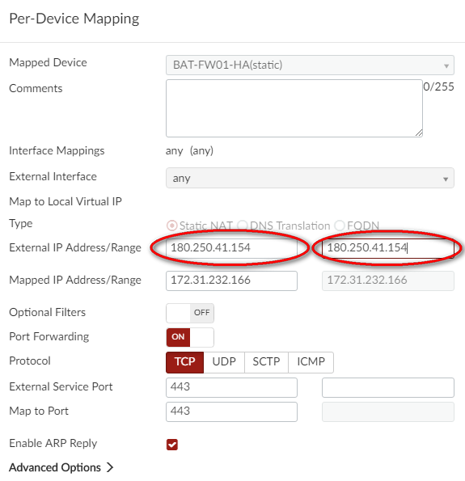

Refresh the device.

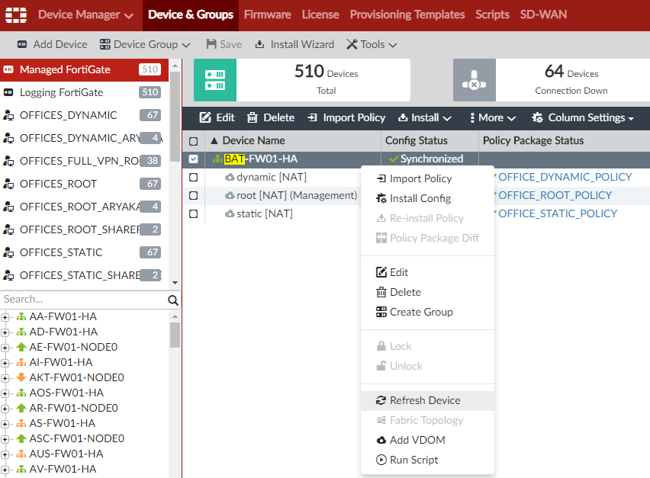

Sync the Static VDOM config.

